Foreign currency: foreign bank notes coins and bank deposits.

Foreign exchange market: the market in which the currency of one country is exchanged for the currency of another.

Foreign exchange rate: the price at which one currency exchanges for another.

Currency depreciation/appreciation: a fall/rise inn the value of one currency in terms of another currency.

Exchange rate is the price of one currency in terms of another, which is determined in the foreign exchange market and the foreign exchange market is a competitive market.

Factors that depends the quantity needs/supply of one currency (i.e. Ca):

1. The exchange rates: influence for 1). Exports effect 2). Expected profit effects

3). Imports effect

1. World demand for Canada exports/Canadian demand for imports
2. Interest rates in the United States/Canada and other countries
3. The expected future exchange rate

Exports Effect: the larger the value of Canadian exports, the greater is the quantity of Canada dollars demanded. The lower the exchange rate, the greater is the value of Canadian exports, so the greater the quantity of Canadian dollars demanded.

Imports Effect: the higher the exchange rate, the greater is the value of Canadian imports, so the greater is the quantity of Canadian dollars supplied.

Expected Profit Effect: the lower is the exchange rate, the larger the expected profit, the greater is the quantity of Canadian dollars demanded.

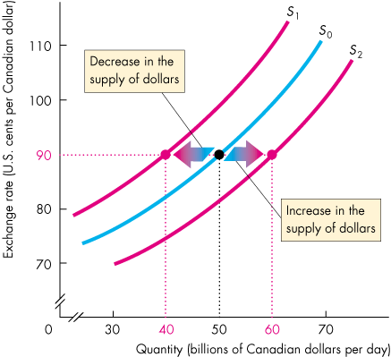Market equilibrium

Factors that influence the quantity of Canadian dollars that people plan to buy:

1. Worlds demand for Canadian exports
2. Canadian interest rate relative to the foreign interest rate
3. The expected future exchange rate

World demand for Canadian exports increases, the demand for Canadian dollars increase.

Canadian interest rate differential: the Canadian interest rate – foreign interest rate

Canadian interest differential rises, the demand for Canadian dollars increases.

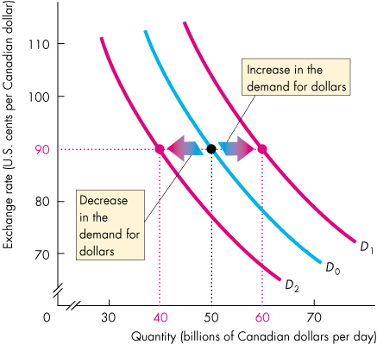Factors that influence the quantity of Canadian dollars that people plan to sell:

1. Canadian demand for imports
2. Canadian interest rates relatives to the foreign interest rate
3. The expected future exchange rate

Arbitrage: the practice of seeking to profit by buying in one market and selling for a higher price in another related market. Arbitrage in the foreign exchange achieves four outcomes:

1. The law of on price: the price will be the same in all locations if an item can be traded in more than one place
2. No round rete parity: there’s no profit in using A to buy B, and then using B to buy A.
3. Interest rate parity: the interest rate on the currency plus the expected rate of appreciation over a given period (the return on a currency)
4. Purchasing power parity: equal value of money

Speculation: trading on the expectation of making a profit